Instruction on how to set up an auto-reply from the DCIDHELP mailbox
- Open Outlook (the actual application, not the web version).
- Go to File and click Add Account.
After you have added the account, you can switch to whichever mailbox you want to view.
- Switch to the DCIDHELP account and click Rules and Alerts.
Select the rule named “Auto reply as a mail”.
Click the link inside the rule — this will open the existing auto-reply email.
Copy the text from that email.
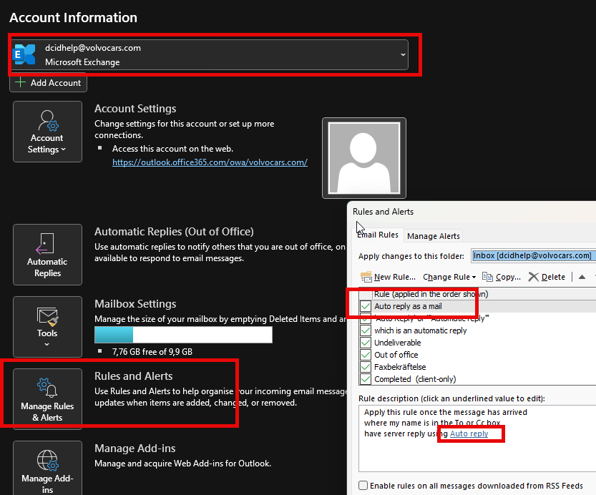
- Create a new rule and select the same conditions:
  - Apply this rule…
  - Where my name…
  - Have server reply…
Click the new link that appears.
- Now you can paste the copied text and modify it as needed.
(You also need to set a subject/title for the email.)
- Name the rule and save it.
Uncheck the box for the old rule and save.
- Send a test email to check that you receive the new auto-reply text.

